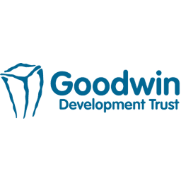
Thank you for showing an interest in working at Goodwin Development Trust. This application will be processed in accordance with the Data Protection and GDPR. Your data will be used for the purpose of recruitment and potential employment.
Are you happy for us to keep your application on our system for 6 months from the application date, and possibly contact you regarding other vacancies?
Yes

No

Please complete all sections of this application form and return to HRDept@goodwintrust.org. Incomplete forms will not be submitted for shortlisting.
Position you’re applying for:

Personal Details
Full Name
Email
Mobile Number
Address Line 1
City/Town
County
Country
Postcode

References
 | Name | Mobile Number | Email
Employment Reference 1
Employment Reference 2

Do you have a current DBS (issued within the last 3 years or on the update service)?
Notice period required in current role
Earliest possible start date
Any prebooked holidays

Qualifications
Place Of Study | Qualifications/Training | Date Achieved

Employment History
Please explain any gaps in employment.
Dates Of Employment | Employer | Job Title | Duties/Responsibilities | Salary | Reason For Leaving

Using up to 500 words, please provide a personal statement outlining the reasons why you’re an ideal candidate for this role, please refer to the job description in your answer.

Equality and Diversity
Goodwin Development Trust wants to meet the aims and commitments set out in its equality policy. This includes not discriminating under the Equality Act 2010, and building an accurate picture of the make-up of the workforce in encouraging equality and diversity.
The organisation needs your help and co-operation to enable it to do this, but filling in this section is voluntary. The information provided will be kept confidential and will be used for monitoring purposes.
Sexual Identity
Age
Ethnicity
Do you consider yourself to have a disability? If so, to what nature?
Sexual Orientation
Religion or Belief?
Please sign and date to confirm that the information provided is complete and correct and that any untrue or misleading information will give my employer the right to terminate any employment contract offered.
Sign
Date
Please now return this form to HRDept@goodwintrust.org OR Goodwin Development Trust, The Octagon, Walker Street, Hull, HU3 2RA.

